**Stock Trading Performance Report**

**Executive Summary**

This report provides a concise overview of stock trading performance for selected Indian companies, including **AXIS Bank, Bank of Baroda, HDFC Bank, Hero MotoCorp, Honda Power, ICICI Bank, Infosys, Maruti Suzuki, Reliance Industries Limited, and SBI**. The analysis covers various timeframes, from daily movements to multi-year trends, highlighting key metrics such as Open, Close, High, and Low prices, along with daily change and overall volume.

**Key Performance Indicators (KPIs)**

The dashboard focuses on the following critical KPIs to assess stock performance:

* **Open Price:** The price at which a stock begins trading for the day.
* **Close Price:** The final price at which a stock trades at the end of the trading day.
* **High Price:** The highest price at which a stock traded during the day.
* **Low Price:** The lowest price at which a stock traded during the day.
* **Daily Change:** The absolute and percentage change in stock price from the previous close.
* **Volume:** The total number of shares traded.

**Company-Specific Analysis Highlights**

**Honda Power (HONDAPOWER)**

* **Current Performance (as of early May 2024):**
  + Price: ₹2.62K
  + Daily Change: -₹45.30 (-1.73%)
* **Historical Trends (2019-2024):** The stock has shown significant fluctuations with notable peaks and troughs across the years. Volume data (Open, Close, High, Low) indicates trading activity in the range of 2.0M to 2.1M units during analyzed periods.

**Infosys (INFY)**

* **Current Performance (as of early May 2024):**
  + Price: ₹1.41K
  + Daily Change: +₹2.90 (+0.21%)
* **Historical Trends (2019-2024):** Similar to Honda Power, Infosys exhibits yearly variations in its Open, Close, High, and Low prices, with trading volumes around 1.7M units. Detailed daily data for August-September 2019 shows specific price movements, for instance:
  + **16 August 2019:** Open ₹780.0, Close ₹774.6, High ₹780.1, Low ₹762.5
  + **23 August 2019:** Open ₹796.5, Close ₹802.2, High ₹810.0, Low ₹795.8

**Timeframe Analysis**

The report provides flexibility in viewing stock performance over various periods:

* **Short-term:** 5 Days (5D), 3 Months (3M)
* **Medium-term:** 6 Months (6M), 1 Year (1Y)
* **Long-term:** 5 Years (5Y), Year-to-Date (YTD), Max (entire available history)

This range allows users to identify both immediate market reactions and long-term investment patterns.

**Data Source and Visualization**

The data appears to be sourced from historical stock market records, presented through candlestick charts for daily/short-term trends and area/bar charts for longer-term yearly performance. The dashboard is designed for clarity and ease of interpretation, utilizing distinct color schemes (white and black themes) to cater to user preferences.

**Visual Representation**

Below is an example of a visual from the dashboard, illustrating the stock performance.

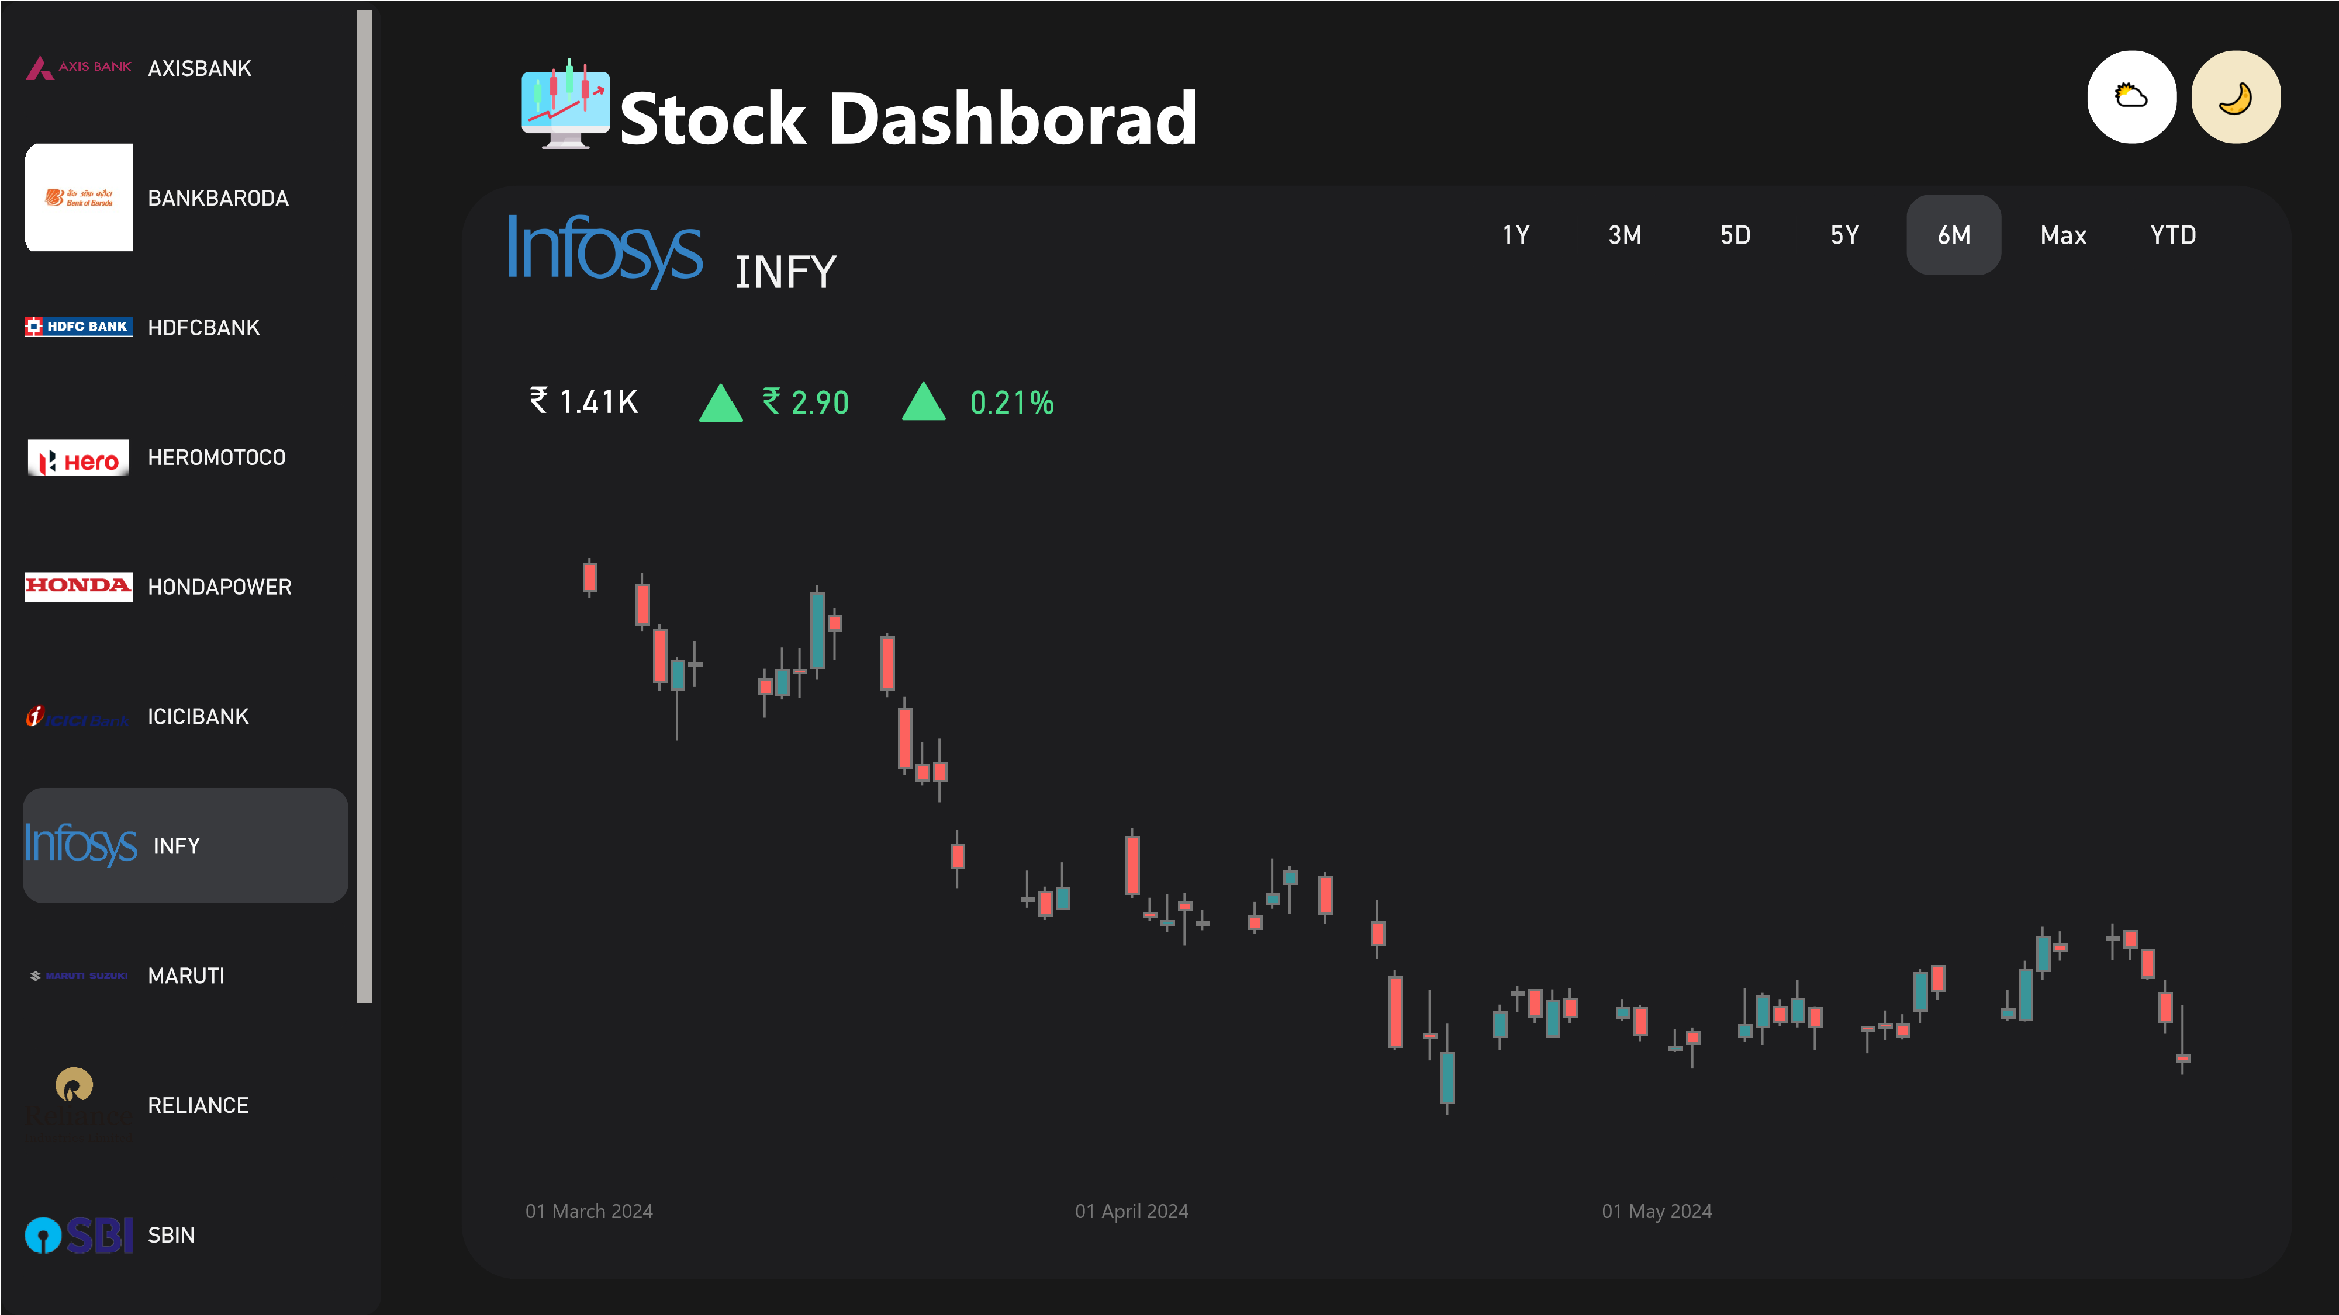

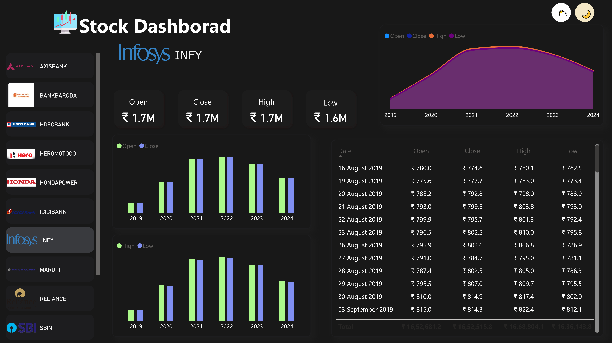

**Conclusion**

The stock trading report provides a robust platform for monitoring and analyzing the performance of key Indian equities. Its comprehensive data presentation and flexible timeframe analysis capabilities make it a valuable tool for investors and financial analysts to track market movements and inform investment strategies.